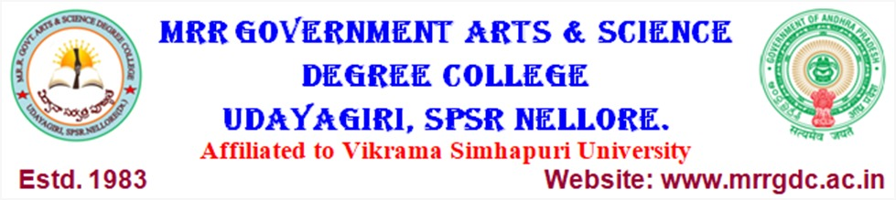

DEPARTMENT OF COMPUTER SCIENCE

Best Practices (2024-2025)
Study Material Distribution to I Year/II Semester Students

- Study material relating to the subject “ C lANGUAGE ” was distributed to students of I Year/II Semester of the academic year 2024-25.
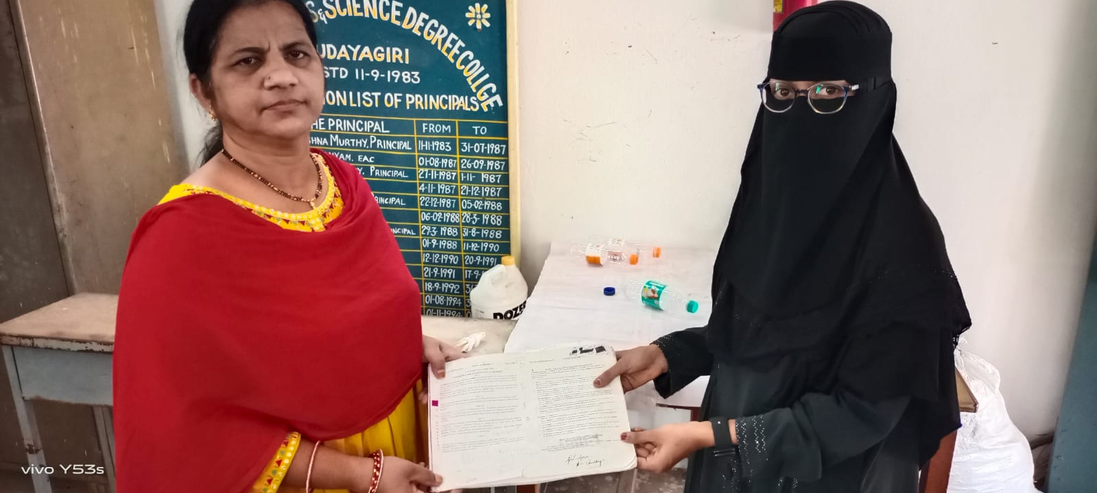

M.R.R. GOVT ARTS & SCIENCE DEGREE COLLEGE, UDAYAGIRI

DEPARTMENT OF COMPUTER SCIENCE

Best Practices (2024-2025)

STUDY MATERIAL DISTRIBUTION TO II YEAR/IV SEMESTER STUDENTS
Study material relating to the subject “Database Management System (DBMS)” was distributed to students of II Year/IV Semester of the academic year 2024-25.

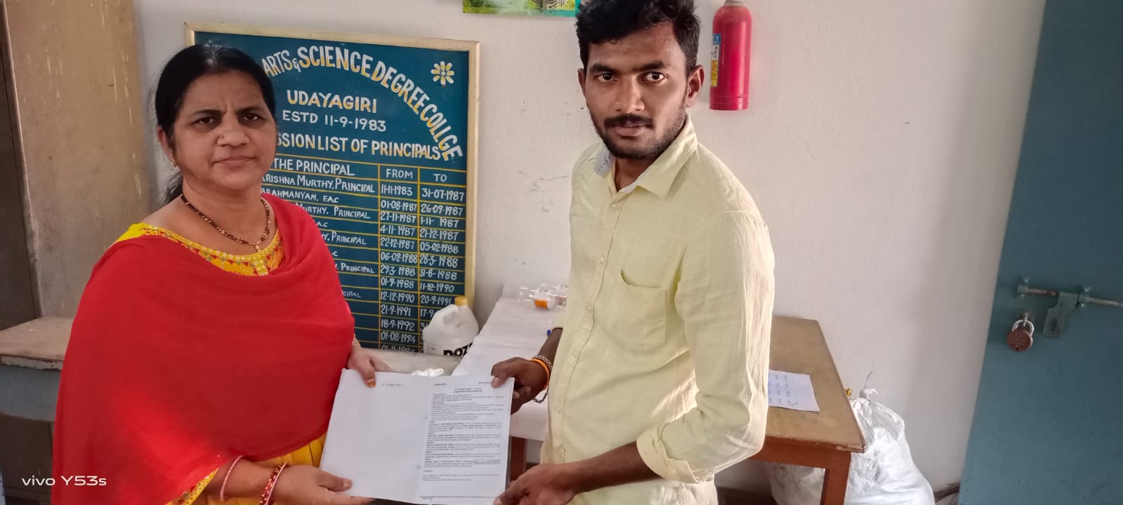

M.R.R. GOVT ARTS & SCIENCE DEGREE COLLEGE, UDAYAGIRI

DEPARTMENT OF COMPUTER SCIENCE

Best Practices (2024-2025)

STUDY MATERIAL DISTRIBUTION TO II YEAR/IV SEMESTER STUDENTS
Study material relating to the subject “Object Oriented Software Engineering (OOSE)” was distributed to students of II Year/IV Semester of the academic year 2024-25.

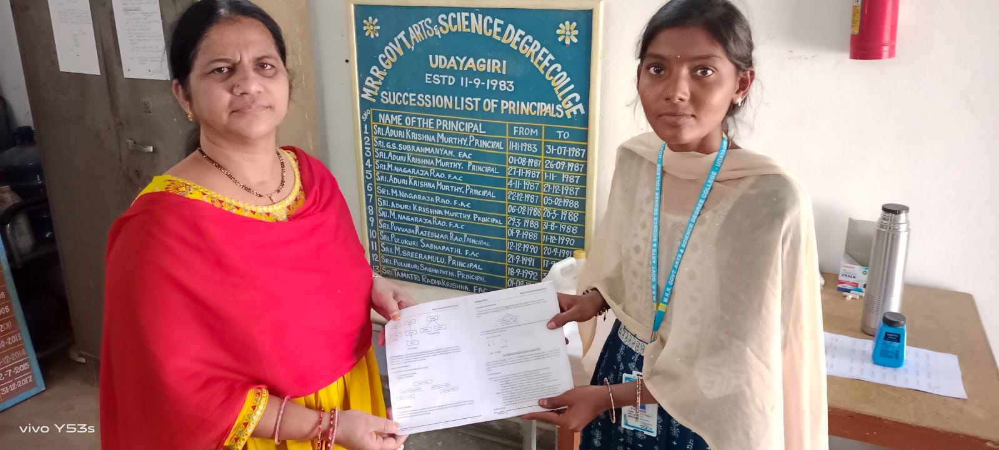

M.R.R. GOVT ARTS & SCIENCE DEGREE COLLEGE, UDAYAGIRI

DEPARTMENT OF COMPUTER SCIENCE

Best Practices (2024-2025)

Working with Shortcuts while using MS-Word and other apps

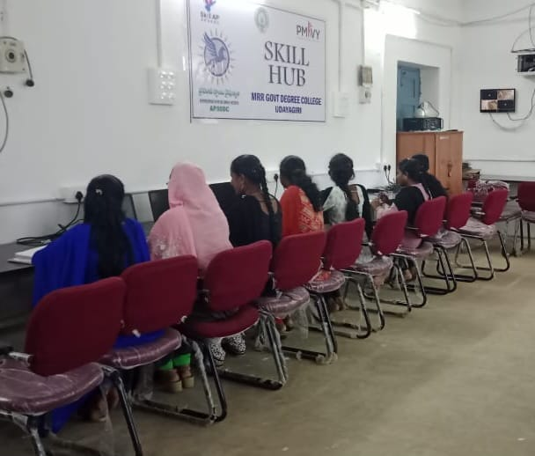

M.R.R. GOVT ARTS & SCIENCE DEGREE COLLEGE, UDAYAGIRI

DEPARTMENT OF COMPUTER SCIENCE

Best Practices (2024-2025)

Usage of Keyboard and Practicing Typing

Identification of Peripheral devices and its Assembling

